
1st Astwood Bank Cub Scout Pack
AGM report
Wow, yet again another really busy year was had by all. We have had something at least once a month on top of our weekly meetings from activity days at Blackwell Adventure and at the Lakeside Campus University of Worcester, the carnival, parades and then Jamboree on the Trail and Jamboree on the Internet. We also threw in the huge camp that was ShireJam, where over 4000 people camped at the Three Counties Showground and were able to visit six different activity zones to do climbing, cave bus, fire lighting, shelter building, circus skills, drumming, water activities and loads more exciting activities as well as our own sleepover and visits to the Theatre both locally and in Birmingham, adventures on the train were huge fun for all!
Our evening meetings have ranged from the Disability Awareness badge where we had a visit from Bunty, Artist, Scientist, Digital Maker badge to Laser Tag, Ministry of Science and Horrible Histories theatre shows, Air Activities, Community Impact and Backwoods Cooking badges.
This year we are looking forward to more district events including a trip to the Black Country Museum, Jamboree on the Trail, District Camp and lots more!

None of these amazing opportunities can be offered to the pack without the support of the parents and the leadership team. We have been lucky enough to have welcomed another section assistant, Ben and continue to be supported by Deb (Shere Khan), Daniel (Kaa), Ed, Ryan and Lucy. Thank you to you all, you are all fabulous!
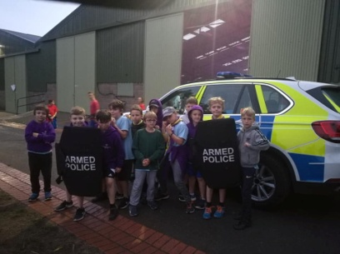
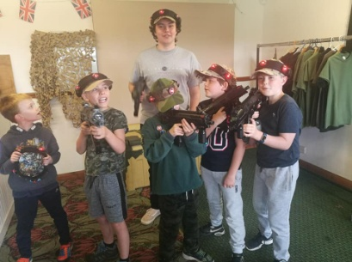
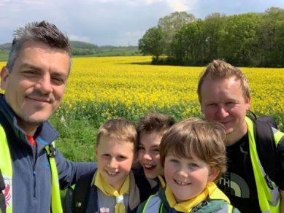
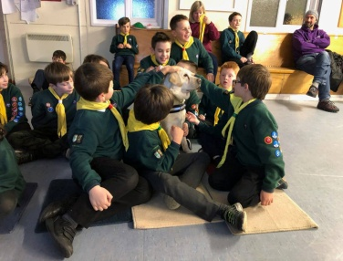

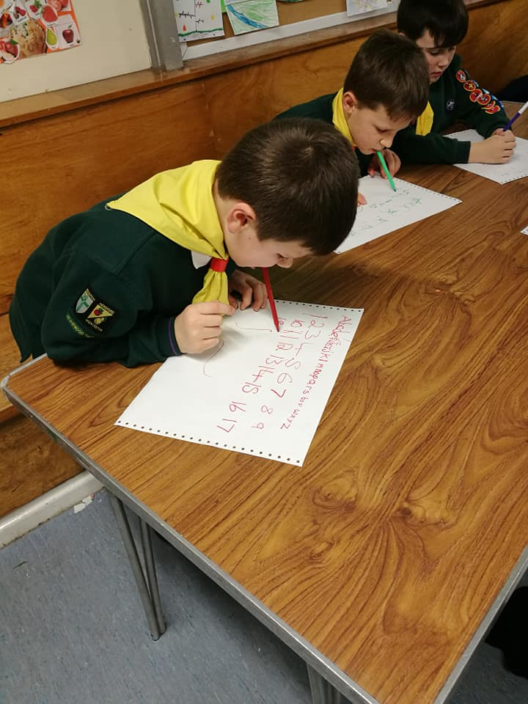
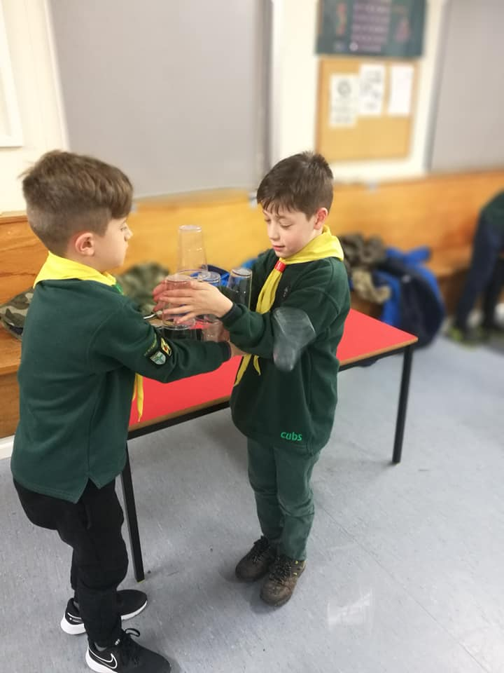
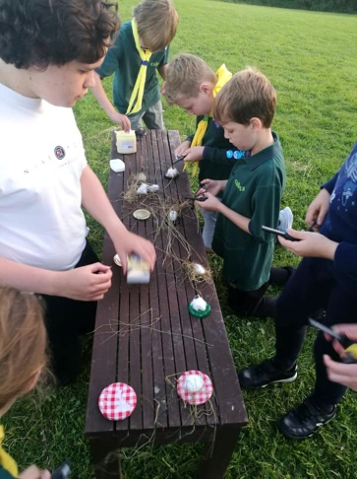
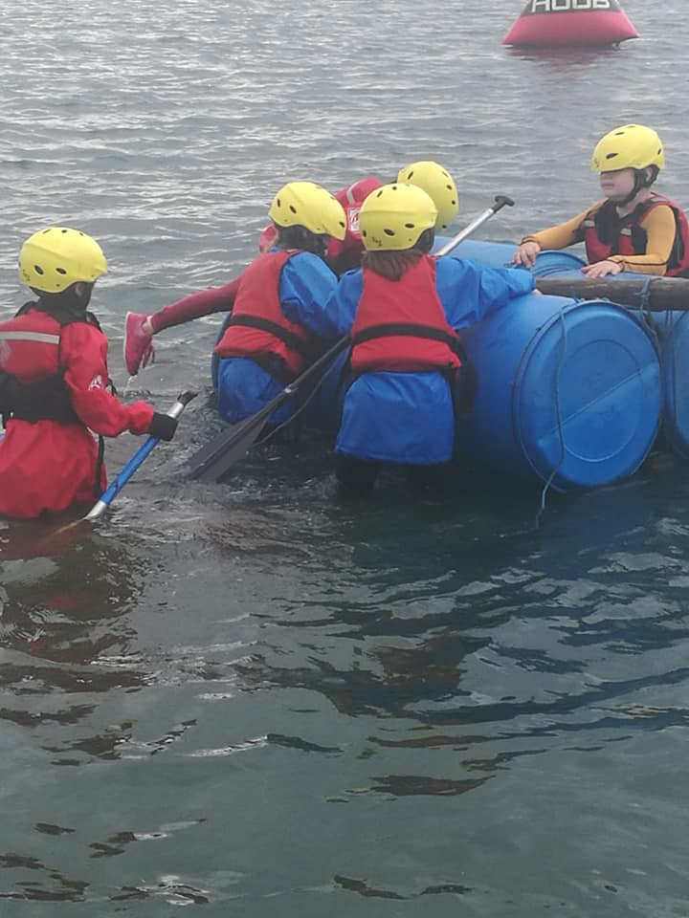

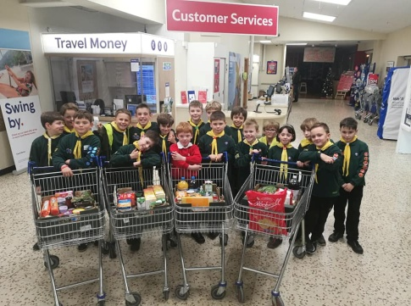
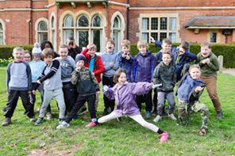
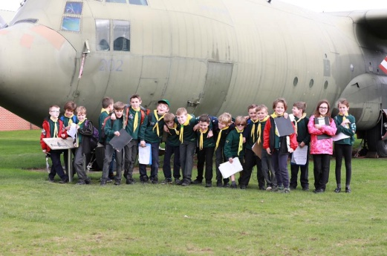

1 – Visit from Bunty the guide dog for Disability Awareness badge
2 – JOTT Jamboree on the Trail attended by 3 cubs and 2 dads (Ben has since become a Section Assistant)
3 – Laser Tag in Studley as team work challenge and end of year celebration in July
4 - ShireJam visit from the Police (Lewis and Harrison’s dad!)
5 – Fire lighting skills on Nashs Acre as part of Outdoor Challenge and Backwoods Cooking badge
6 – Team working
7 – Water activity day at Lakeside Campus University of Worcester
8 – Disability awareness, writing with wrong hand or with mouth
9 – District visit to RAF Cosford
10 – District activity day at Blackwell Adventure
11- Community Impact badge, food bank shopping at Tesco

Since lockdown we have taken part in weekly Zoom meetings, starting with a scavenger hunt, entertainers badge, joke telling and riddles. We renewed our promise alongside Crabbs Cross and the District Commissioner and took part in the Thursday carers clap in uniform for St George’s day. We are working on the communicators badge, have done some cooking, quizzes and played wink murder and charades! We have also taken part in the first virtual group camp alongside the Scouts and some beavers. (Oh and invested a new cub live over Zoom with her grandparents watching from their home – a very special moment) At home the cubs have been working on the Home Help, Gardeners, animal carer and chefs badges to name but a few. We have over 70 badges to be awarded!

